Appendix 2 – Contractual Provisions, Assurances, and Certifications
Section A – Contractual Provisions
State of Kansas
Department of Administration
DA-146a (Rev. 07-19)

CONTRACTUAL PROVISIONS ATTACHMENT
Important: This form contains mandatory contract provisions and must be attached to or incorporated in all copies of any contractual agreement. If it is attached to the vendor/contractor's standard contract form, then that form must be altered to contain the following provision:
The Provisions found in Contractual Provisions Attachment (Form DA-146a, Rev. 07-19), which is attached hereto, are hereby incorporated in this contract and made a part thereof.
The parties agree that the following provisions are hereby incorporated into the contract to which it is attached and made a part thereof, said contract being the
_____________ day of _____________, 20____ .

- Terms Herein Controlling Provisions: It is expressly agreed that the terms of each and every provision in this attachment shall prevail and control over the terms of any other conflicting provision in any other document relating to and a part of the contract in which this attachment is incorporated. Any terms that conflict or could be interpreted to conflict with this attachment are nullified.
- Kansas Law and Venue: This contract shall be subject to, governed by, and construed according to the laws of the State of Kansas, and jurisdiction and venue of any suit in connection with this contract shall reside only in courts located in the State of Kansas.
- Termination Due to Lack Of Funding Appropriation: If, in the judgment of the Director of Accounts and Reports, Department of Administration, sufficient funds are not appropriated to continue the function performed in this agreement and for the payment of the charges hereunder, State may terminate this agreement at the end of its current fiscal year. State agrees to give written notice of termination to contractor at least thirty (30) days prior to the end of its current fiscal year and shall give such notice for a greater period prior to the end of such fiscal year as may be provided in this contract, except that such notice shall not be required prior to ninety (90) days before the end of such fiscal year. Contractor shall have the right, at the end of such fiscal year, to take possession of any equipment provided State under the contract. State will pay to the contractor all regular contractual payments incurred through the end of such fiscal year, plus contractual charges incidental to the return of any such equipment. Upon termination of the agreement by State, title to any such equipment shall revert to contractor at the end of the State's current fiscal year. The termination of the contract pursuant to this paragraph shall not cause any penalty to be charged to the agency or the contractor.
- Disclaimer of Liability: No provision of this contract will be given effect that attempts to require the State of Kansas or its agencies to defend, hold harmless, or indemnify any contractor or third party for any acts or omissions. The liability of the State of Kansas is defined under the Kansas Tort Claims Act (K.S.A. 75-6101, et seq.).
- Anti-Discrimination Clause: The contractor agrees: (a) to comply with the Kansas Act Against Discrimination (K.S.A. 44-1001, et seq.) and the Kansas Age Discrimination in Employment Act (K.S.A. 44-1111, et seq.) and the applicable provisions of the Americans With Disabilities Act (42 U.S.C. 12101, et seq.) (ADA), and Kansas Executive Order No. 19-02, and to not discriminate against any person because of race, color, gender, sexual orientation, gender identity or expression, religion, national origin, ancestry, age, military or veteran status, disability status, marital or family status, genetic information, or political affiliation that is unrelated to the person's ability to reasonably perform the duties of a particular job or position; (b) to include in all solicitations or advertisements for employees, the phrase "equal opportunity employer"; (c) to comply with the reporting requirements set out at K.S.A. 44-1031 and K.S.A. 44-1116; (d) to include those provisions in every subcontract or purchase order so that they are binding upon such subcontractor or vendor; (e) that a failure to comply with the reporting requirements of (c) above or if the contractor is found guilty of any violation of such acts by the Kansas Human Rights Commission, such violation shall constitute a breach of contract and the contract may be cancelled, terminated or suspended, in whole or in part, by the contracting state agency or the Kansas Department of Administration; (f) Contractor agrees to comply with all applicable state and federal anti-discrimination laws and regulations; (g) Contractor agrees all hiring must be on the basis of individual merit and qualifications, and discrimination or harassment of persons for the reasons stated above is prohibited; and (h) if is determined that the contractor has violated the provisions of any portion of this paragraph, such violation shall constitute a breach of contract and the contract may be canceled, terminated, or suspended, in whole or in part, by the contracting state agency or the Kansas Department of Administration.
- Acceptance of Contract: This contract shall not be considered accepted, approved or otherwise effective until the statutorily required approvals and certifications have been given.
- Arbitration, Damages, Warranties: Notwithstanding any language to the contrary, no interpretation of this contract shall find that the State or its agencies have agreed to binding arbitration, or the payment of damages or penalties. Further, the State of Kansas and its agencies do not agree to pay attorney fees, costs, or late payment charges beyond those available under the Kansas Prompt Payment Act (K.S.A. 75-6403), and no provision will be given effect that attempts to exclude, modify, disclaim or otherwise attempt to limit any damages available to the State of Kansas or its agencies at law, including but not limited to, the implied warranties of merchantability and fitness for a particular purpose.
  - Representative's Authority to Contract: By signing this contract, the representative of the contractor thereby represents that such person is duly authorized by the contractor to execute this contract on behalf of the contractor and that the contractor agrees to be bound by the provisions thereof.
- Responsibility for Taxes: The State of Kansas and its agencies shall not be responsible for, nor indemnify a contractor for, any federal, state or local taxes which may be imposed or levied upon the subject matter of this contract.
- Insurance: The State of Kansas and its agencies shall not be required to purchase any insurance against loss or damage to property or any other subject matter relating to this contract, nor shall this contract require them to establish a "self-insurance" fund to protect against any such loss or damage. Subject to the provisions of the Kansas Tort Claims Act (K.S.A. 75-6101, et seq.), the contractor shall bear the risk of any loss or damage to any property in which the contractor holds title.
- Information: No provision of this contract shall be construed as limiting the Legislative Division of Post Audit from having access to information pursuant to K.S.A. 46-1101, et seq.
- The Eleventh Amendment: "The Eleventh Amendment is an inherent and incumbent protection with the State of Kansas and need not be reserved, but prudence requires the State to reiterate that nothing related to this contract shall be deemed a waiver of the Eleventh Amendment."
- Campaign Contributions / Lobbying: Funds provided through a grant award or contract shall not be given or received in exchange for the making of a campaign contribution. No part of the funds provided through this contract shall be used to influence or attempt to influence an officer or employee of any State of Kansas agency or a member of the Legislature regarding any pending legislation or the awarding, extension, continuation, renewal, amendment or modification of any government contract, grant, loan, or cooperative agreement.
Appendix 2 – Contractual Provisions, Assurances, and Certifications
Section B – Local Assurances
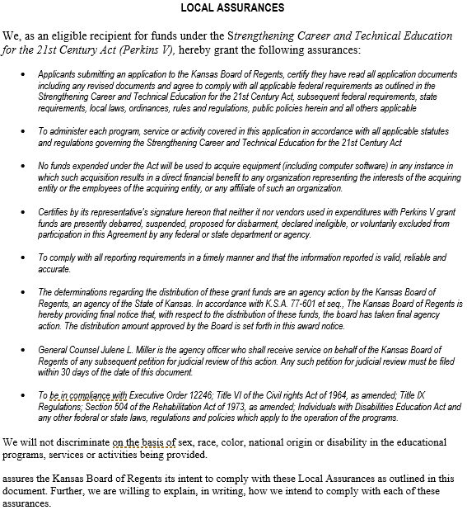

Appendix 2 – Contractual Provisions, Assurances, and Certifications
Section C – Certifications
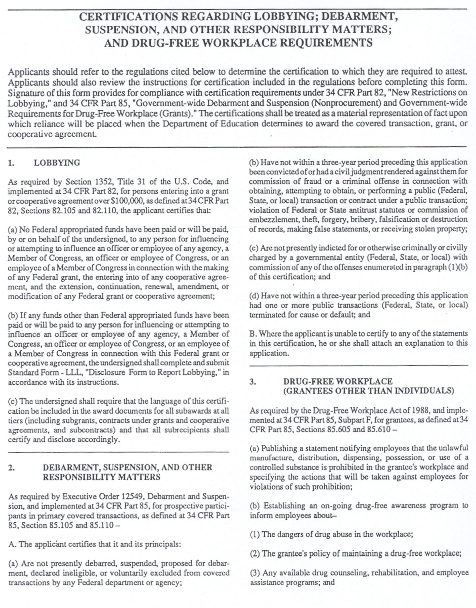
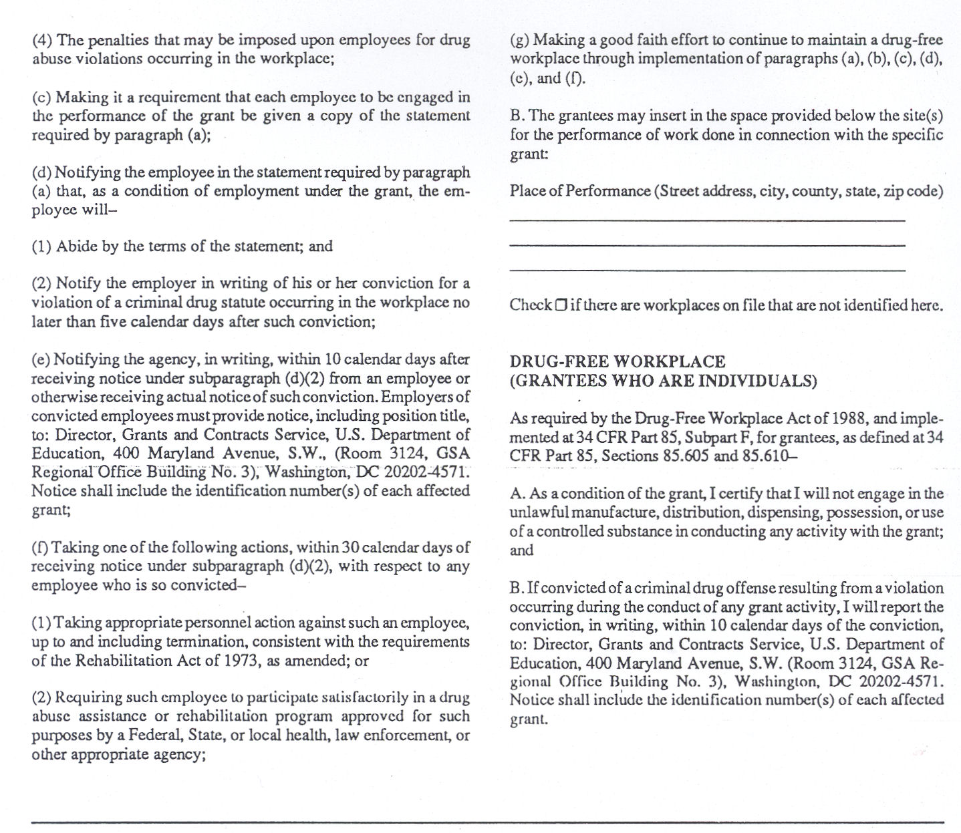

Physical address here

As the duly authorized representative of the applicant, I hereby certify that the applicant will comply with the Contractual Provisions, Local Assurances, and the above Certifications

Signature of President or Authorized Administrator Date

Printed Name Title

Appendix 2 – Contractual Provisions, Assurances, and Certifications
Section D – Transfer of Local Funds – Consortium Only

TRANSFER OF POSTSECONDARY LOCAL FUNDS
(CONSORTIUM ONLY)

Use this form for transferring Strengthening Career and Technical Education for the 21st Century Act (Perkins V) postsecondary funds from one eligible recipient to another eligible recipient providing service on behalf of the institution. Submit an original copy for each institution transferring funds into a consortium/partnership.

I certify that

Transferring Institution Name

is transferring all postsecondary local grant funds made available under Strengthening Career and Technical Education for the 21st Century Act (Perkins V) for FY_________ to

Receiving Institution Name

The funds will be used as described in the program improvement grant application package of the receiving institution. The uses of funds must be mutually beneficial to Perkins-approved CTE programs at all institutions in the consortium.

________________________________ _____________________________________
Original Signature of President or Authorized Original Signature of President or Authorized
Administrator Transferring Funds Administrator Receiving Funds

Date: ___________________________ Date: __________________________

**************************

STATE USE ONLY
***************************

I hereby certify that the transferring institution is eligible for the funds identified above and the receiving institution is eligible to receive said funds.

_________________________________________ ___________________________
Signature of KBOR Authorized Representative Date

